**Welcome Back Turtle Assignment:**

1. 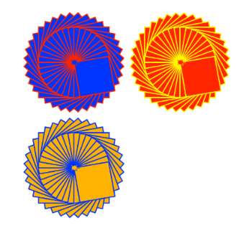Create a Python Turtle program to do the following:
2. Draw an interesting shape using multiple basic shapes   
   and pen colors.
3. Use the **goto(x,y)** function to move the starting point for the shape   
   to a different location on the output window.
4. Use a **counted loop** to draw multiple copies of your shape at different   
   positions on the output window.
5. Use the **input()** function to ask for a number of times to repeat the shape. Use this number to control the repeat of the counted loop.
6. Extension. Check the repeat number input to make sure it is a valid number and that it is between the range of 1 to 6 repeats.
7. Use print screen to copy and paste an image of your program output below.

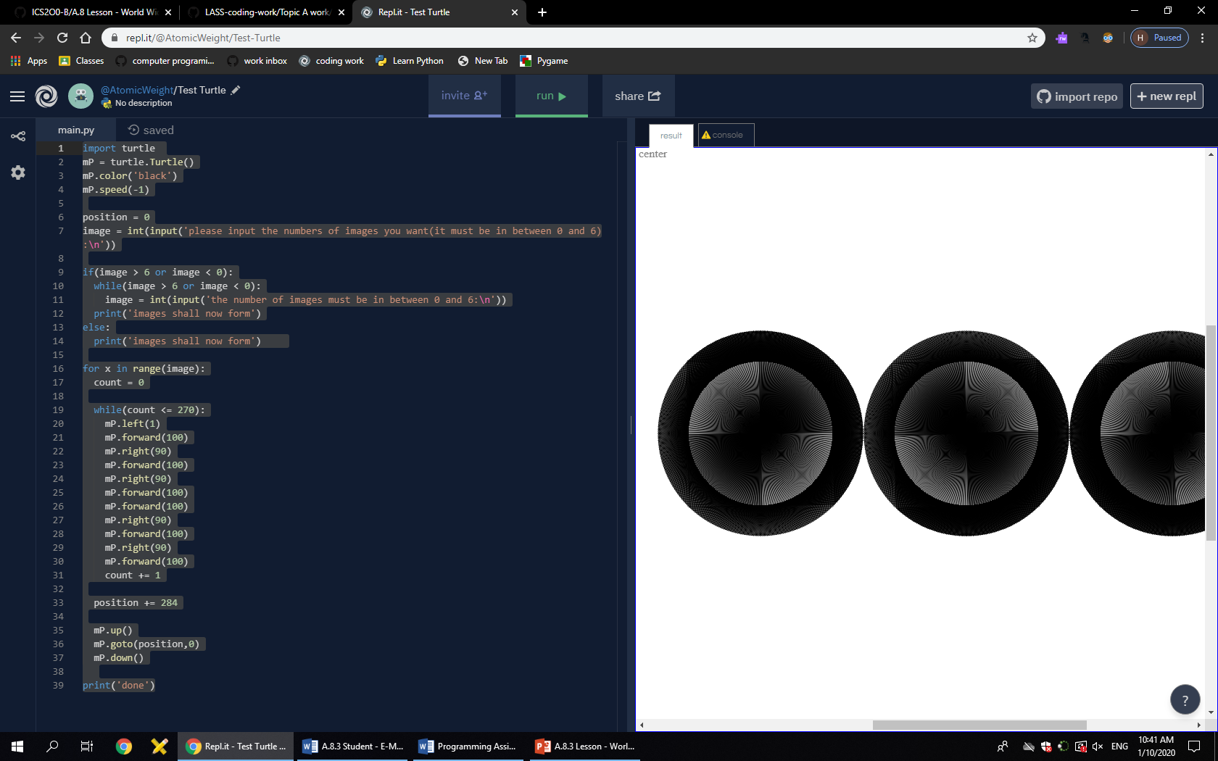

1. Provide a listing of your Python program below.
   1. import turtle
   2. mP = turtle.Turtle()
   3. mP.color('black')
   4. mP.speed(-1)
   5. position = 0
   6. image = int(input('please input the numbers of images you want(it must be in between 0 and 6):\n'))
   7. if(image > 6 or image < 0):
   8. while(image > 6 or image < 0):
   9. image = int(input('the number of images must be in between 0 and 6:\n'))
   10. print('images shall now form')
   11. else:
   12. print('images shall now form')
   13. for x in range(image):
   14. count = 0
   15. while(count <= 270):
   16. mP.left(1)
   17. mP.forward(100)
   18. mP.right(90)
   19. mP.forward(100)
   20. mP.right(90)
   21. mP.forward(100)
   22. mP.forward(100)
   23. mP.right(90)
   24. mP.forward(100)
   25. mP.right(90)
   26. mP.forward(100)
   27. count += 1
   28. position += 284
   29. mP.up()
   30. mP.goto(position,0)
   31. mP.down()
   33. print('done')